Skills Workshops: Video 1-3
Speakers: Denny Dupps and Jack Broering
Dates: Monday, July 10, 2017, Monday, July 17, 2017, and Thursday, July 20, 2017
Time: 10:30 – 12:00 PM each day
Venue: University of Cincinnati, Swift Hall, room 516
Prepared by:
Kat Roedig, The Summit Country Day School, Cincinnati, Ohio
RET Participant for Project #4: “Air Quality Monitoring and Emissions Characterization Near a Major Roadway”
These sessions were given by Denny Dupps and Jack Broering on Monday, July 10, 2017, Monday, July 17, 2017, and Thursday, July 20, 2017 from 10:30 – 12:00 PM each day at the University of Cincinnati in Swift Hall, room 516. Denny Dupps’s has a background of technological expertise, working at Indian Hill School District for the past 48 years. Jack Broering is a retired engineer, having worked for The Dow Chemical Company for 33 years as a process improvement engineer.
Video 1
Before this workshop began, Denny and Jack had RET participants make a copy of their video 1 workshop files to use during the session, see Figure 1. Jack started the presentation by outlining the objectives of the workshop, namely to know the summer video requirements, create a project folder, use various animation techniques, use transitions between slides, adjust slide transition timing, insert a voiceover and video clip, and save our project as an MPEG-4. This outline, was displayed slide-by-slide in a Power Point. After explaining the objectives, Jack had the RET participants open Power Point on their laptops and then he moved forward to help the RET participants create a video with acknowledgements and an inserted video clip using Power Point. This was completed by giving the RET participants a step-by-step outline on two sheets of paper to follow along with what Jack was doing on his own computer. Jack ended the session with showing RET participants how to save the video as an MPEG-4, see Figure 2.
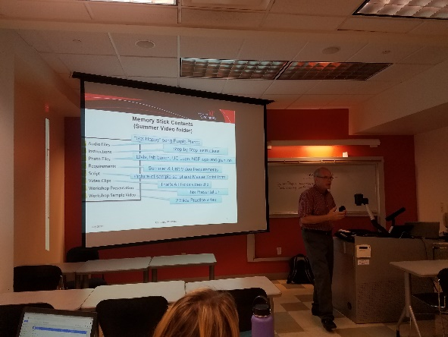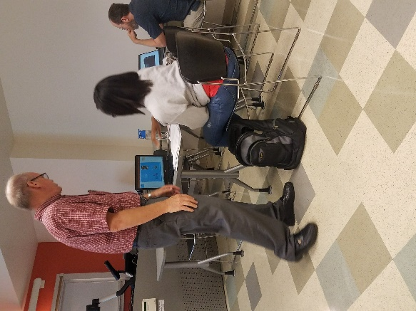
Figure 1: Jack Showing Workshop Files Figure 2: Jack Showing how to Save Video

Video 2
Before this workshop began, Denny and Jack had RET participants download Windows Movie Maker. Denny started the presentation by outlining the objectives and goals (see Figure 3) of the workshop, namely to add text, photos, and video clips to Movie Maker, convert a YouTube video using keepvid, use Movie Maker to shorten a clip, download a copyfree music file using Purple-Planet, adjust audio levels using Movie Maker, and upload a video to YouTube and insert on a Wiki. This outline, was displayed slide-by-slide in a Power Point. Denny started this workshop by having RET participants open Windows Movie Maker and create a title slide. Animations and transitions were also added to this title slide. After this was completed and saved, RET participants opened a new Windows Movie Maker to edit an animation to add to the previous movie creation. Once the animation was downloaded from YouTube and then edited through Windows Movie Maker, RET participants added this animation to their previous movie creation. The project from video 1 session was also added to this Movie Maker presentation after the edited animation. To wrap it up, Denny showed RET participants how to download music from Purple Planet and put this music into the presentation. Denny then showed how to publish the video to YouTube and how to embed this YouTube link onto the RET participants’ Wiki.
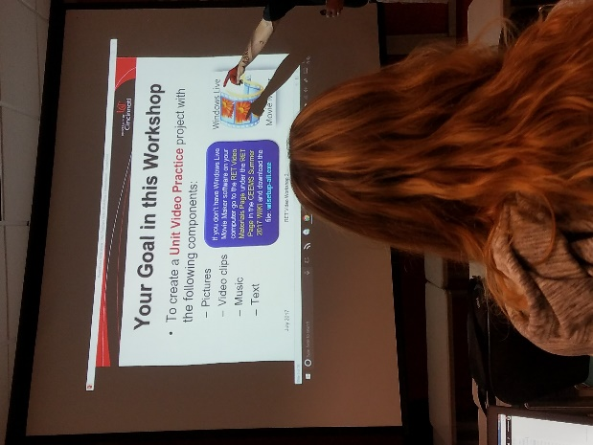
Figure 3: Denny Showing Goals of the Workshop
Video 3
Denny started this workshop as he did in the previous ones by outlining the objectives of the workshop, namely, to understand the Unit Video requirements, understand the importance of File Management, learn of sources to collect and/or convert media for your video, review summer videos, and participate in a Q&A session. This outline, see Figure 4, was displayed slide-by-slide in a Power Point. This session gave RET participants many helpful resources for constructing their Unit Videos that they will complete after they implement their lessons. He ended by having a Q&A session to make sure all RET participants understand what is expected of them to complete after their unit is implemented.
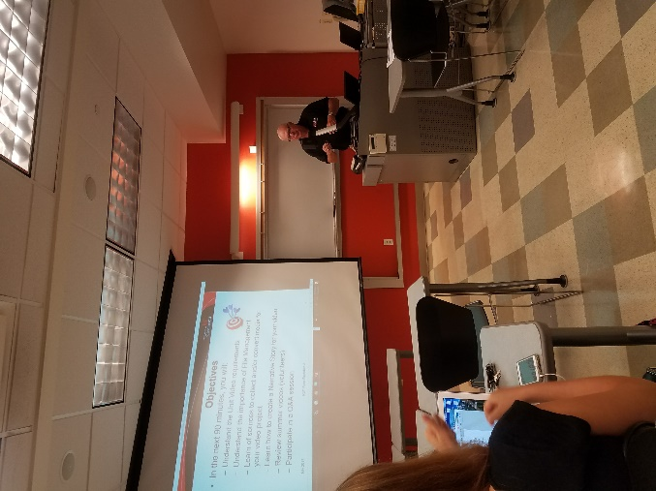
Figure 4: Denny Showing Outline of Objectives of Workshop
In summation, the RET participants learned (1) how to create a video using Power Point (2) how to create a video using Windows Movie Maker, and (3) what the requirements for the Unit Video include and how to manage files to complete this video. These workshops were helpful for RET participants, especially those who had no experience in creating videos.

